Car Dealership Management System

1. **Creating the tables**

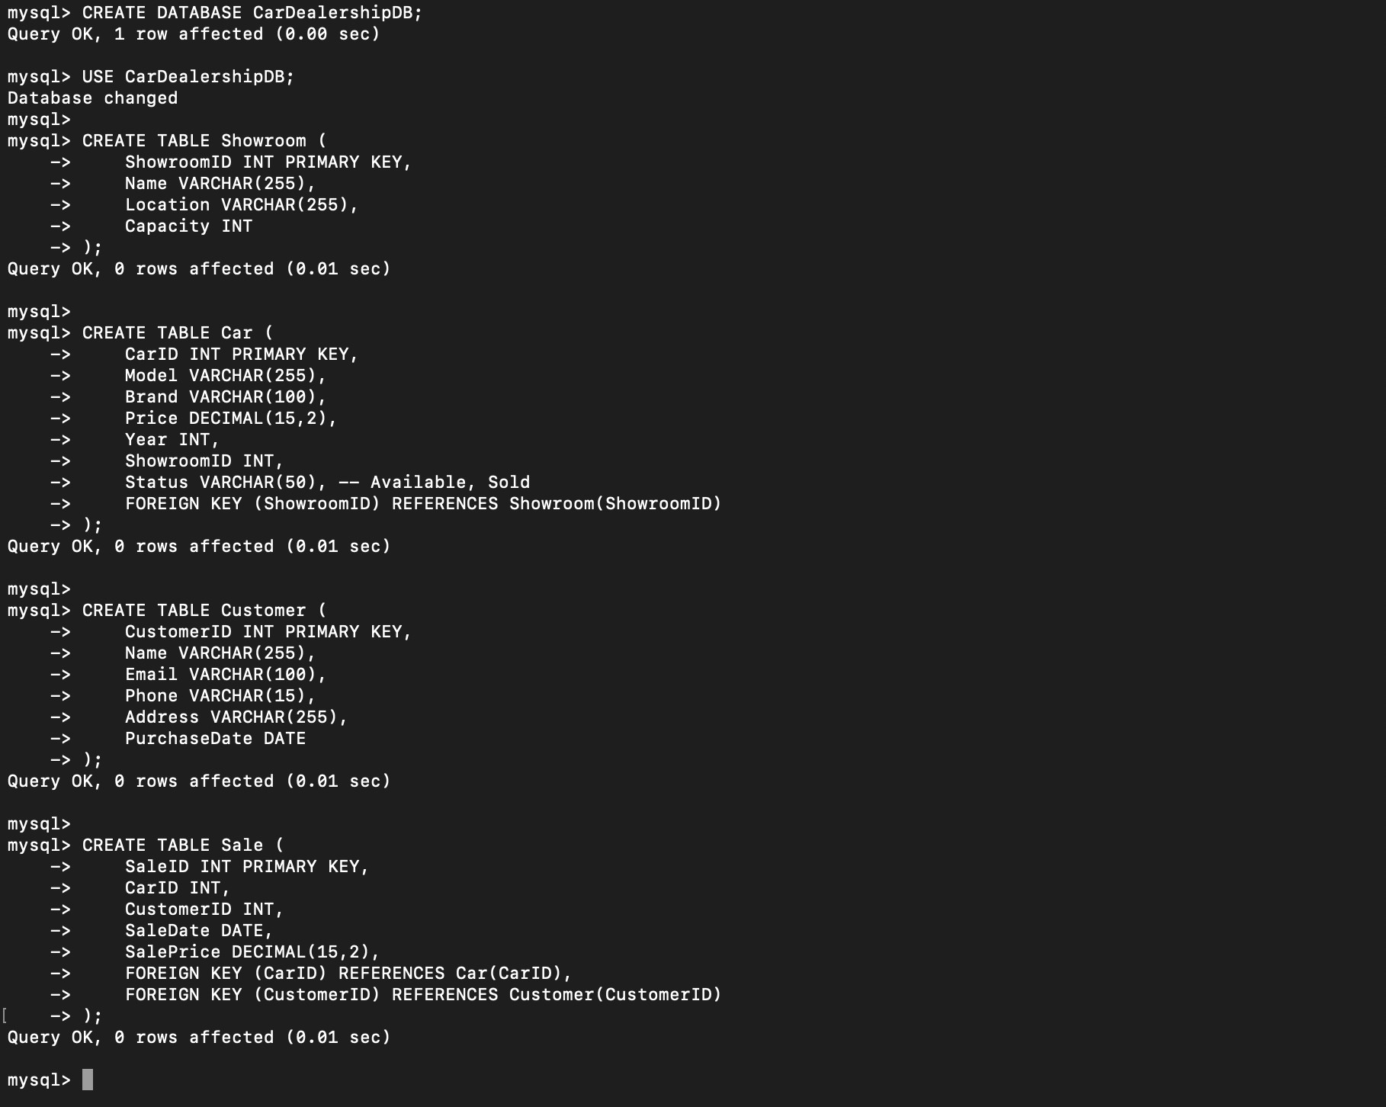

1. **Inserting sample data**

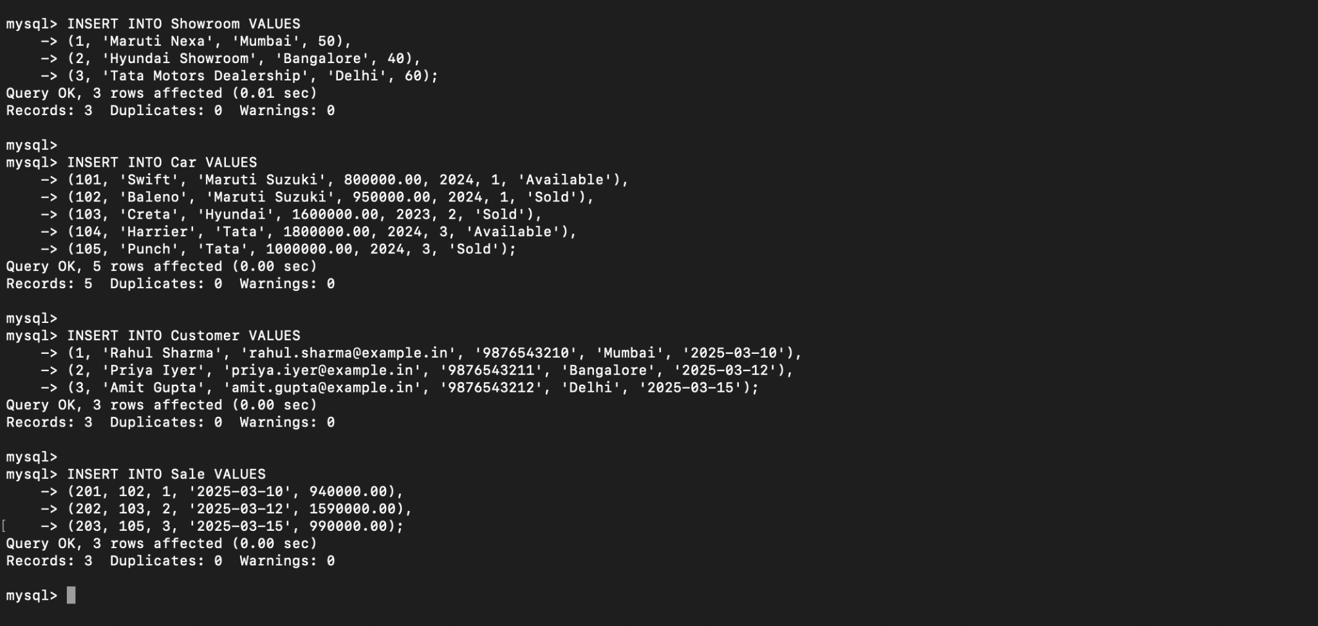

1. **Retrieve all available cars in a specific showroom**

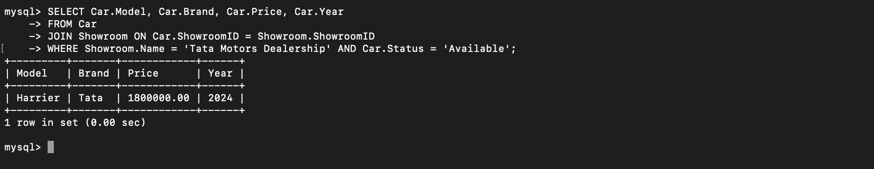

1. **Find the most sold car model in the last 6 months**

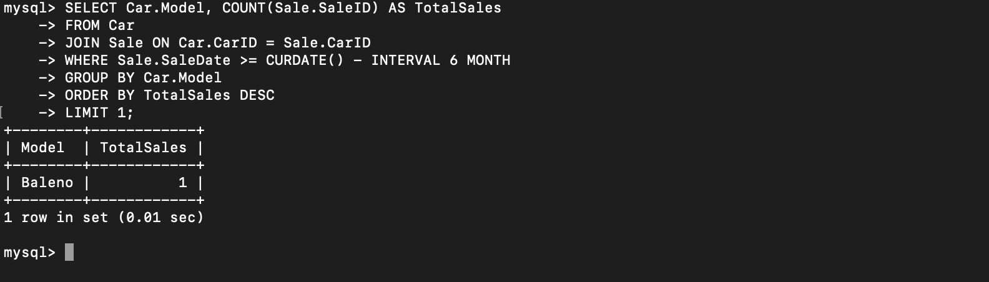

1. **Retrieve details of customers who have made a purchase**

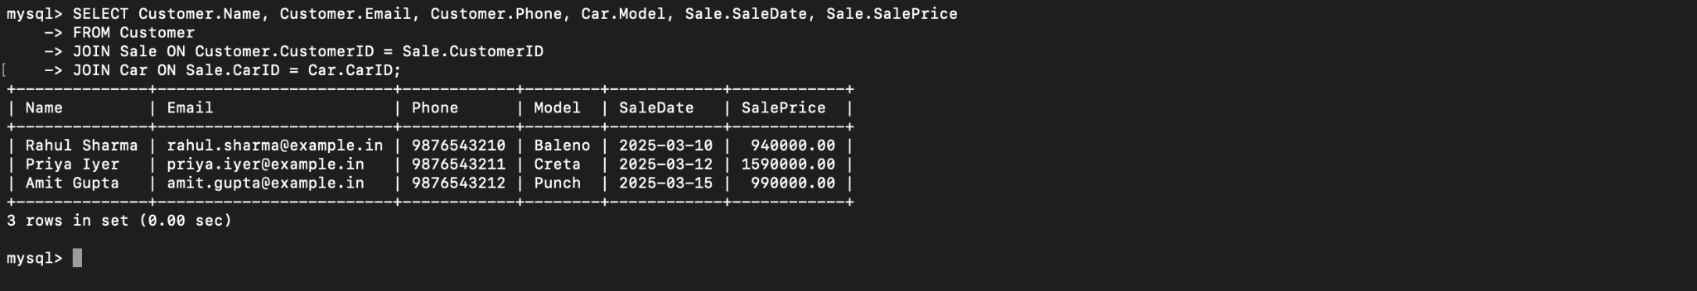

1. **Find the showroom with the highest sales revenue**

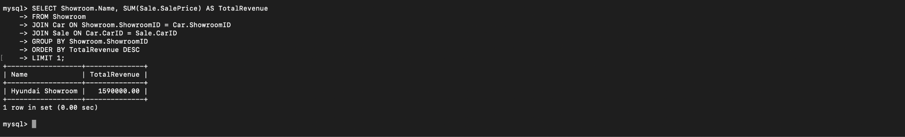

1. **Display all cars that have not been sold yet**

